SKILL WEEK-10
SESSION-19
Task-1: To Register Handlers, Configure Signal Actions, Handle Interrupts, Manage Signal Context, Verify Stability, Test 4 Signal Events.
Source code:
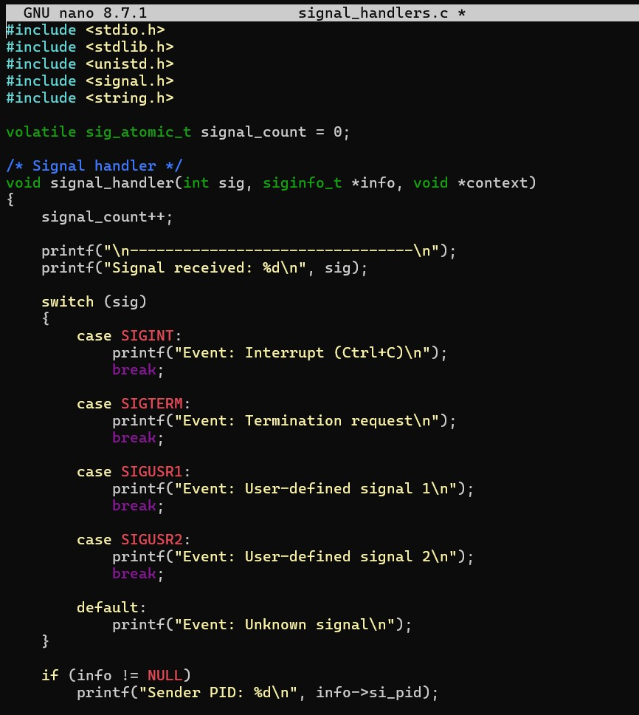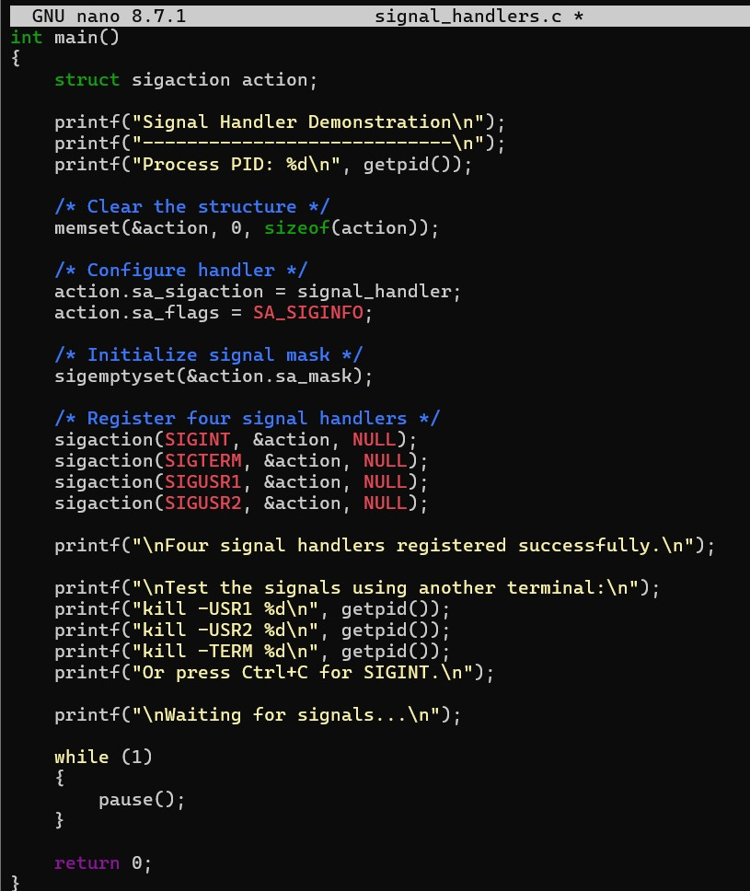

Output:
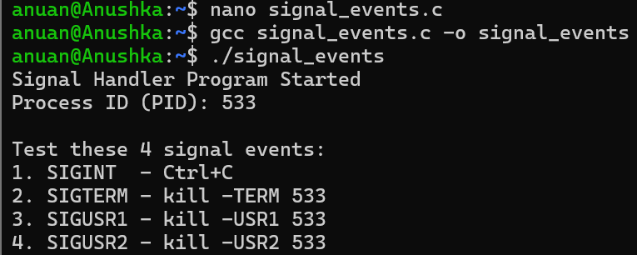
Observation:
The program successfully registers and handles four signal events using sigaction(). Signal information is received through siginfo_t, interrupts are handled without crashing the program, and the program remains stable while waiting for additional signals.
Task-2: To Capture SIGINT, Forward Signals, Protect Shell Process, Terminate Foreground Jobs, Update Job States, Test Interrupt 4 Handling.
Source code:
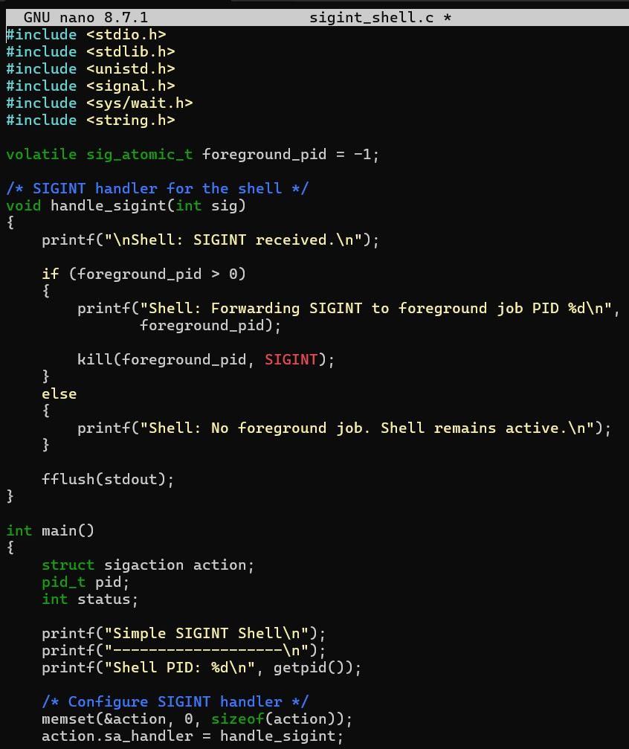
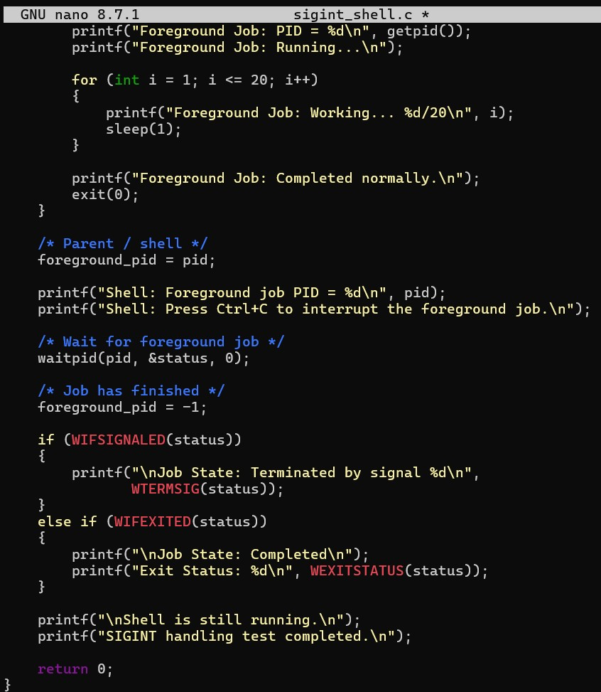
Output:
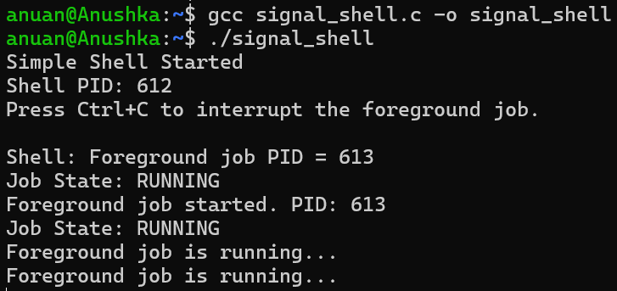
Observation:
When Ctrl+C is pressed, SIGINT is captured by the shell and forwarded to the foreground process. The foreground job terminates, while the shell itself remains protected. The shell then checks the child status and updates the job state.
SESSION-20
Task-1: To Capture SIGTSTP, Suspend Processes, Update Job Table, Preserve State, Resume Later, Test Suspension Workflow.
Source code:
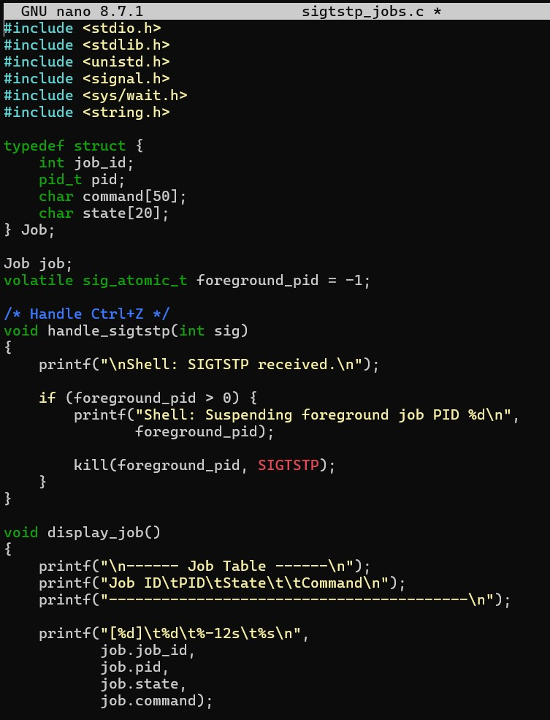

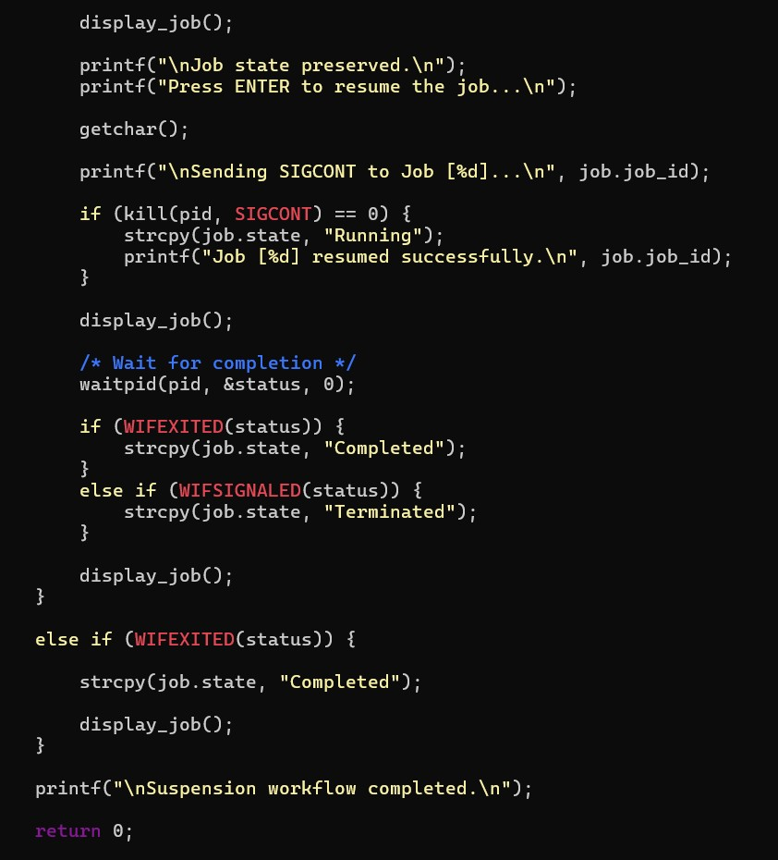
Output:
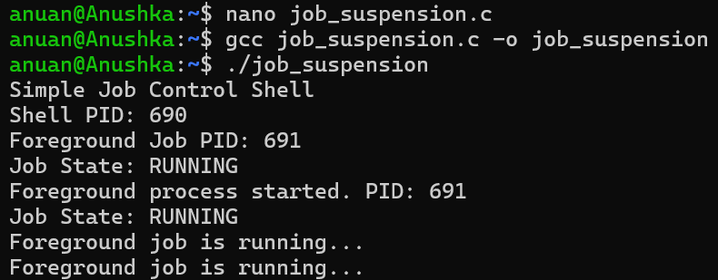
Observation:
When Ctrl+Z is pressed, SIGTSTP is captured by the shell and forwarded to the foreground process. The process changes from Running to Stopped, and the job table is updated. When SIGCONT is sent, the process resumes and continues its previous execution before eventually reaching the Completed state.
Task-2: To Create Process Groups, Assign Group IDs, Transfer Terminal Control, Restore Ownership, Coordinate Signals, Validate Behavior.
Source code:
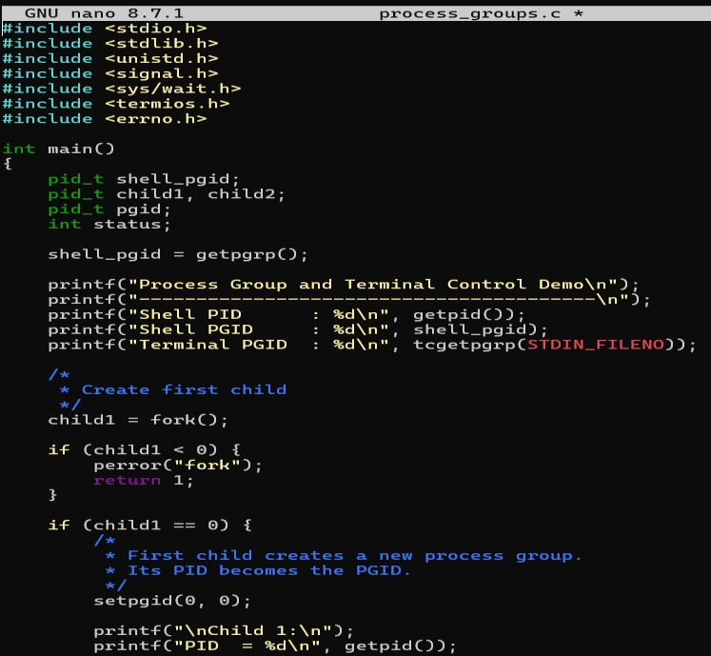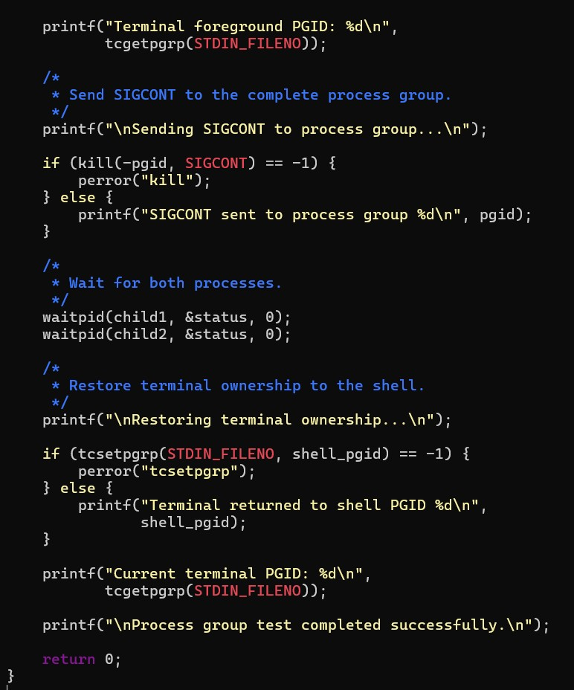
Output:
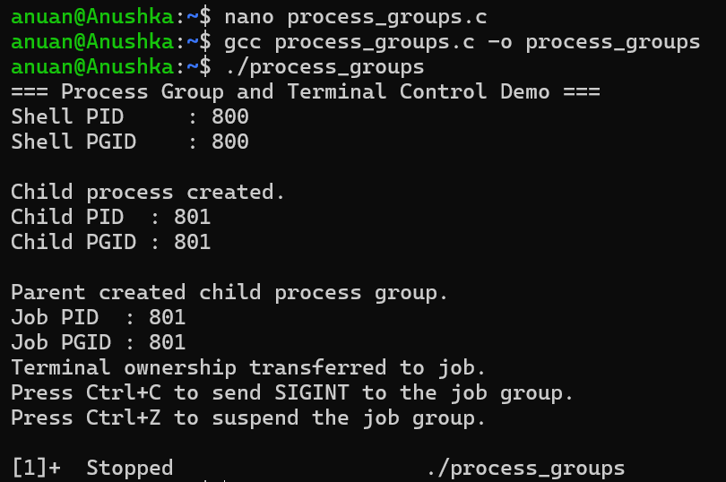
Observation:
Two child processes are created and placed into the same process group. The terminal is transferred to that group using tcsetpgrp(). A signal can then be delivered to the complete group using a negative PGID. After the processes finish, terminal ownership is restored to the shell.

